|  |  |  |  |  |
| --- | --- | --- | --- | --- |
| [ESP8266 BASIC](http://www.esp8266basic.com/) | |  |  |  | | --- | --- | --- | |  |  | Top of Form    Bottom of Form | |

How to flash your chip.

Download the package

[Download the package from the download page](http://www.esp8266basic.com/download.html)  
Run "ESP_Basic_Flasher.exe"

Set up the flasher

|  |  |
| --- | --- |
| Select Your com port number and flash memory size for your chip. Picture |  |

Hook up your ESP in flashing mode

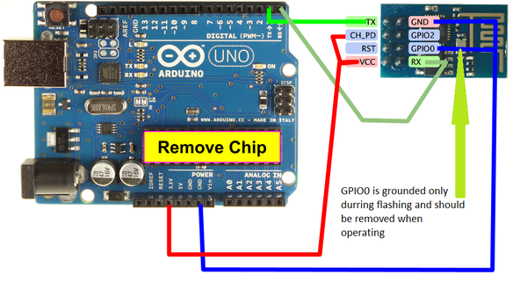

Hook your ESP8266 module up in flashing configuration as shown.  
Click the "Firmware Flash" button.  
Wait for the flash to finish with out errors. IF there are any errors check your wiring.  
Reset the ESP8266 module with out GPIO 0 grounded.

Connect to the ESP network

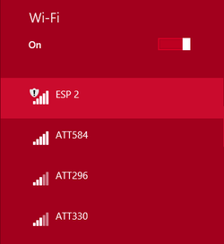

The module will attempt to connect to the last network it was connected to. Because this module has never been connected before it will start its own access point.  
  
  
Connect to the "ESP" access point

Access your ESP via the web browser.

[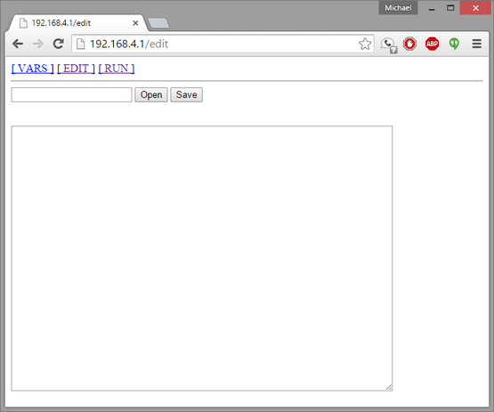](http://www.esp8266basic.com/editor-interface.html)

Goto <http://192.168.4.1/edit> in your browser. You should see a screen that looks like this.  
You can now use the edit area to type basic programs for the ESP8266.  
Saving the program with no file name will make it the default program that is loaded upon restart of module likewise clicking the open button with out a program name specified will open the default program.  
To connect to you you wifi access point see the [wifi example.](http://www.esp8266basic.com/wifi-station--ap-examples.html)

[Head on over hear to learn about the user interface.](http://www.esp8266basic.com/editor-interface.html)